FOR IMMEDIATE RELEASE

IN REAL LIFE ANNOUNCES “TONIGHT BELONGS TO YOU” US HEADLINE TOUR

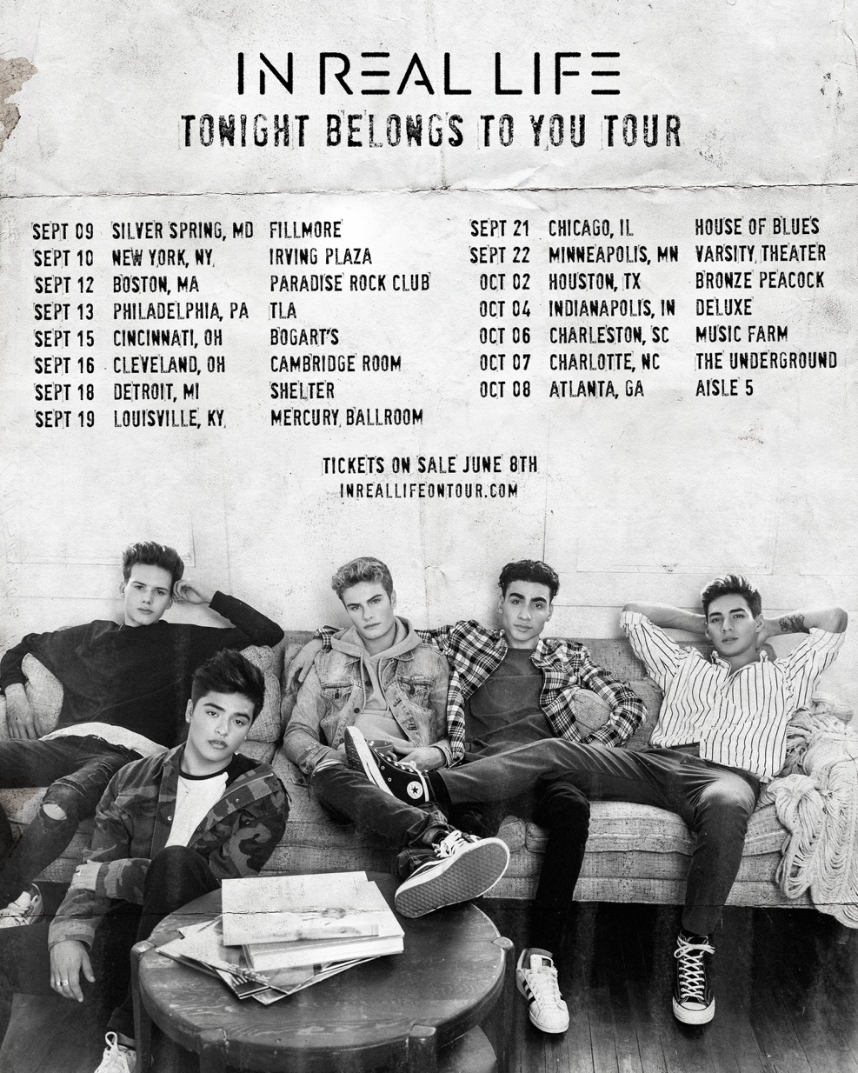
(Burbank, CA) – June 4, 2018 – Hollywood Records recording artists, In Real Life, have announced their “Tonight Belongs To You” US Headline Tour fresh off their summer dates on the American Idol Live! Tour. The band will kick off the Tonight Belongs To You Tour September 9th in Silver Springs, Maryland at The Fillmore. Exclusive pre-sales begin on Tuesday, June 5, at 10AM local for Citi, and Wednesday, June 6, at 10AM local for Live Nation and Ticketmaster. Tickets go on sale to the public on Friday, June 8th at 10AM local.

In Real Life’s current single, “Tattoo (How ‘Bout You)” (HERE) is soaring up the Top 40 charts at #28 and climbing. “Tattoo” is the follow up to their debut single, “Eyes Closed,” (HERE) which debuted at the top of the iTunes chart, and reached #3 of Spotify’s Global Viral Chart. The band recently made a foray into singing in Spanish with their track “How Badly.” (HERE) In Real Life will release a new track, “Tonight Belongs To You,” on July 6th. In Real Life have recently performed on Jimmy Kimmel Live, Good Morning America, Live! With Kelly & Ryan, TRL, and Despierta America. The band is the first group to be voted together in US television history on ABC’s “Boy Band.” The band is comprised of Sergio Calderon, Michael Conor, Chance Perez, Drew Ramos and Brady Tutton; each bringing their unique talents and personalities to the group. Their gorgeous five-part harmonies are accented by the emotionally gritty raps of Michael Conor. In Real Life are managed exclusively

IN REAL LIFE MEMBERS
Sergio is the heart of in Real Life; the first one to greet fans and make friends – the de-facto mayor of the group. Sergio grew up in Redwood City, California with his twin brother, sisters and Mexican-immigrant parents. He is an ace soccer player and fan, and is fluent in Spanish.
Michael is the rebel of the band, and the rapper. His mercurial wit and emotional grit keeps the band as interesting as his freestyle raps. Michael grew up in Shaker Heights, Ohio, and is also a classically trained violinist; he’s been known to break out his violin during In Real Life’s live shows.
Chance is the heartthrob of the group; mysterious and tender at the same time. A young father to 3-year-old Brooklyn, Chance is always thoughtful and poised. Had it not been for music, Chance would have pursued a career as a paramedic. He hails from Seal Beach, California.
Drew is the romantic of In Real Life, often making grand gestures to his loved ones and fans. Drew grew up in The Bronx, NY, with a single mom, and busked in subways to help make ends meet. His personal devotion carries through to his impassioned vocals.
Brady is the showman of the band, growing up in musical theater, and singing multiple genres of music. He suffered a severe stutter as a child, and the therapy that helped him overcome this was singing. Brady is from Shorewood, Wisconsin.

The “Tonight Belongs To You” Tour dates are as follows:

September 9 Silver Spring, MD The Fillmore
September 10 New York, NY Irving Plaza
September 12 Boston, MA Paradise Rock Club
September 13 Philadelphia, PA TLA
September 15 Cincinnati, OH Bogart’s
September 16 Cleveland, OH Cambridge Room
September 18 Detroit, MI Shelter
September 19 Louisville, KY Mercury Ballroom
September 21 Chicago, IL House of Blues
September 22 Minneapolis, MN Varsity Theater
October 2 Houston, TX Bronze Peacock
October 4 Indianapolis, IN Deluxe
October 6 Charleston, SC Music Farm
October 7 Charlotte, NC The Underground
October 8 Atlanta, GA Aisle 5

SOCIALS
YOUTUBE: http://hollywoodrecs.co/InRealLifeYT
VEVO: http://hollywoodrecs.co/InRealLifeVevo
TWITTER: @InRealLife
INSTAGRAM: @InRealLife
FACEBOOK: https://www.facebook.com/InRealLifeOfficial/

Press Contacts:
Lillian Matulic / Hollywood Records
Lillian.Matulic@disney.com
Lyssa Hurvitz / Hollywood Records
Lyssa.Hurvitz@disney.com

