**HOLLYWOOD  BLACK.JPG PUBLICITY**

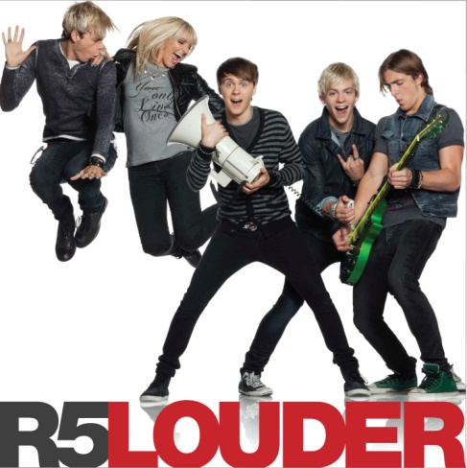

**R5** L to R**: Riker** (bass/vocals), **Rydel** (keyboard/vocals), **Ratliff** (drums), **Ross** (lead vocals/guitar), **Rocky** (guitar/vocals**)**

[**R5**](http://www.R5rocks.com)

**"LOUDER"**

Before [R5](http://vevo.ly/ybpp4B) entered the studio to record their Hollywood Records debut album no one told them what to do. No one needed to. The band knew exactly what they wanted: to make an album perfect for playing in the car. And by that they meant summer nights, with the top down, cruising down the highway and cranking the music up. Not just loud. **Louder**.

In its 11 tracks, **Louder** establishes R5 as the foremost up-and-coming young pop/rock band today. "We wanted to put out a fun album," says **Rydel Lynch** (keyboards/vocals) who, with her brothers **Riker** (bass/vocals), **Ross** (lead vocals/guitar) and **Rocky** (guitar/vocals), and best friend **Ratliff** (drums) make up R5. "We wanted to make an upbeat and Inspirational album you want to play 24/7."

Teaming up with producers Emanuel "Eman" Kiriakou and Andrew Goldstein, the members of R5 effortlessly express the spirit by which they live in their music. "We have such a good time together," says Riker. "We wanted the songs to make people feel the fun, too."

The album wastes no time getting to it, starting with the debut single, [**"Pass Me By**,**"**](http://www.youtube.com/watch?v=lVe6SEH9IsM) a playful jet engine of a rocker featuring Ross’ sly vocals and a killer chorus. “What I try to do is add certain subtleties to the songs with my voice: certain cracks, weird pronunciations, and random slides,” says Ross. “When I adlib I try to hit unorthodox soul notes that will compel the audience.”

Next comes the explosive **"Forget About You**,**"** about an emotional freefall sparked by love, while the arena-sized **"Ain’t No Way We’re Goin’ Home"** instantly becomes a two-for-the-road classic. “It has this cool delayed guitar thing,” says Rocky of the track. “We cut that and said, ‘Yo, that’s freaking sick!’”

The album downshifts to pure pop on tracks like **"I Want U Bad"** and **"If I Can’t Be With you,"** both tales of unrequited love, with a humorous spin. "In the bridge, there’s an Atari video game synth sound," notes Ratliff of the latter song. "Little things like that make a record really special."

Rydel rocks the mic on **"Love Me Like That,"** an irresistible party track that’ a whole lotta rhythm and a little bit blues. Ross then slows things down on the surprisingly heartfelt ballad, **"One Last Dance,"** while on **"Fallin’ For You"** he counts off the reasons why that one special girl is so special.

**"Cali Girls,"** written by Riker and Rocky, updates the Beach Boys favorite subject, only this time sunnier and sexier. "We love the Beach Boys, who were a big inspiration," Riker adds. "’Cali Girls’ was a huge step for us. We’ve been playing it live and fans love it." The album wraps with **"Here Comes Forever"** (also written by Riker and Rocky), which riffs on clever movie references to sum up the perfect romance.

Here comes forever. That could easily describe the mood of the band, as their five-year odyssey to success reaches this critical crossroad.

The R5 story actually begins almost a decade ago in Littleton, Colo., the Denver suburb the Lynch siblings grew up in. Riker, the eldest, showed a knack for singing and performing early on while Rocky was the first to take up guitar. Thanks to a steady diet of Elvis, Beatles and Rolling Stones served up by their parents, and a healthy dose of sibling rivalry, the Lynchs started taking music seriously.

“We were always meant to be on stage together. When we were really little, we’d put on shows in the basement," remembers Rocky. "Our mom would get on the phone and invite all our relatives to come over. We charged family members a dollar to watch us.”

The family moved to Los Angeles in 2007 to get their careers going in acting, dance, music and commercials. But forming a band of their own took precedence. Though the Lynch siblings all played instruments, none played drums. That’s when they turned to their friend Ratliff, and the line-up – not to mention the fifth "R" – was complete. “We’ve always been a group,” notes Rocky. “We grew up as a group. Then we met Ratliff and pulled him right in.” In 2009 the band self-released an EP, Ready Set Rock and in April of 2012 they signed a record deal with Hollywood Records.

Meanwhile Riker and Ross each found success on television. Riker became Jeff, one of the member of the Warblers, the a cappella group featured in *Glee*, while Ross stars in his own series, *Austin & Ally*, now in its third season on the Disney Channel. That led to Ross’ lead role in the 2013 Disney Channel original movie *Teen Beach Movie*, which spawned a #1 hit soundtrack album and a top 10 album for six consecutive weeks on the *Billboard* 200 chart. “Time management is a huge factor in my life,” notes Ross. “After taping the show, I’ll take a red eye flight, play a show that day and then fly back that same night sometimes. It’s a lot. I never really get time off but I’m having so much fun I wouldn’t change a thing.”

None of the success deterred R5 from its central focus. For much of the last two years, the band honed its performing chops, headlining and selling-out shows across the U.S., Canada, Europe and Australia. In their biggest show to date, the band played for a resounding 16,000 screaming fans. "There’s something cool that happens when we’re on stage together," Riker says. "There’s nothing more exciting in the world. We try to be very personable, and meet the entire audience after shows. We hope the fans we meet on the road stick with us forever."

To give fans a taste of what was to come, in early 2013 R5 released a 4-song EP titled Loud. As with the new album, producers Kiriakou and Bogart worked with the band, writing three tracks for the band with Riker and Ross contributed one of their own. Between the recordings, touring, TV and generally universally positive buzz, R5 now boasts more than 4 million YouTube views, 500,000 Facebook likes, a million instagram followers and more than 1.5 million combined Twitter followers.

One explanation for R5’s growing success is the closeness among the group members. “I’ve been performing with these guys my whole life,” says Ross. “When they aren’t there I feel a piece of me is missing.” “We love each other so much,” adds Rydel. “We’re best friends.” That comes across on stage, especially as the band grows tighter with every performance. “We strive to get to the point of almost improvising,” adds Ratliff. “Being able to listen to your band mates, ‘read’ what they’re saying without talking: It’s cool to see the whole stage moving and grooving as one.”

They can expect to see a lot more moving and grooving once the new album hits. As much fun as they’re having, the band members know how fortunate they are to be able do what they love and share that with the world.

“There are so many crazy things happening every day,” says Riker. “Not everybody had a nice upbringing like we did. But if someone is feeling down, and then they listen to our music and come to our shows, hopefully for that one night they can forget their problems and feel like nothing else matters. Let’s just enjoy one another and just have an awesome time together.”

0813 ###